**Gull Ahmed Mens kameez Shalwar Summer Collection**

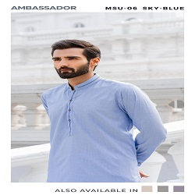

FLORIDA- SKY BLUE COTTAN KAMEEZ SHALAWAR

PKR6992.00

* Jacquard Shirt: 3.5 Meters
* Trouser: 3.5 Meter
* Size: Medium

**MORE INFORMATION:**

* color: Sky blue
* Wear Type: Semi-Formal
* Product Category: Semi-Formal Kameez Shalwar
* Volume : Volume 4 2021
* Collection: Festive Affair '22
* Fabric: Cottan
* Size Avalible: Small , Medium ,Large
* Disclaimer: Due to the photographic lighting & different screen calibrations, the colors of the original product may slightly vary from the picture